Distributed Memory Model in High Performance Computing

1. Introduction
The distributed memory model is a type of computer architecture where each processor has its own private memory. Unlike shared memory systems, no global memory is available to all processors. To exchange data, processors must communicate using message passing techniques. This model is widely used in supercomputers, clusters, and parallel computing systems due to its scalability.

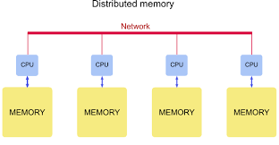

2. Architecture
- Each processor (CPU or core) has its own local memory (RAM).
- Processors are connected via a communication network such as Ethernet or InfiniBand.
- No direct access to another processor’s memory is possible.
Conceptual Diagram:
Processor 1 ---- Memory 1
Processor 2 ---- Memory 2
Processor 3 ---- Memory 3
... ...
Processor N ---- Memory N

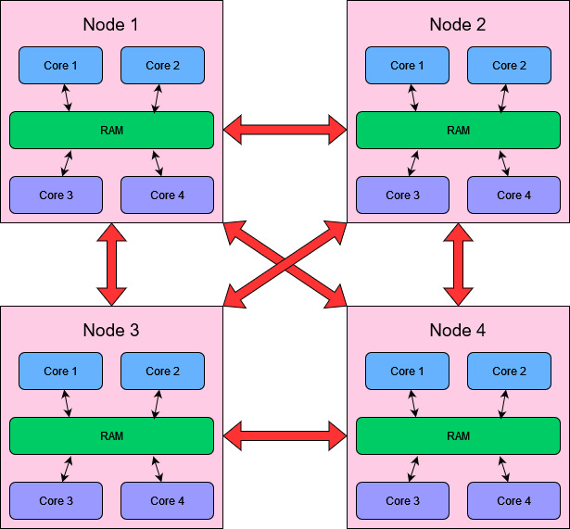

3. Working Principle
1. Problem Decomposition: The main problem is divided into smaller subproblems.
2. Data Distribution: Each processor stores only the data required for its subproblem.
3. Independent Computation: Each processor performs calculations using its local data.
4. Communication: If a processor needs data from another processor, it must send and receive messages.
5. Synchronization: Processors coordinate at certain points to align their progress.

4. Communication Model
- Message Passing: Explicit communication using send/receive functions.
- Common Libraries:
• MPI (Message Passing Interface) → Most widely used in HPC.
• PVM (Parallel Virtual Machine) → Older library.
- Communication Overheads:
• Latency (time to initiate message).
• Bandwidth (amount of data transferred per second).

5. Characteristics
- Local Memory Access: Very fast.
- Remote Memory Access: Requires communication → much slower.
- Scalable: Can scale to thousands of nodes.
- Explicit Programming: Programmer manages data movement and synchronization.

6. Advantages
1. Scalability → System can be expanded to thousands of processors.
2. No Memory Bottleneck → Each processor has independent memory bandwidth.
3. Cost-Effective → Can be built using commodity hardware (clusters of PCs).
4. Fault Isolation → Failure in one node doesn’t crash the entire system.

7. Disadvantages
1. Programming Complexity → Programmer must handle explicit communication.
2. Communication Overhead → Sending messages across the network is slower than local memory access.
3. Load Balancing → Tasks must be evenly distributed, or some processors may remain idle.
4. Data Duplication → If multiple processors need the same data, copies must be sent.

8. Applications
- Scientific Simulations (weather forecasting, climate modeling, molecular dynamics).
- High-Performance Databases (Google Bigtable, Amazon Dynamo).
- Big Data Analytics (Hadoop, Spark – though hybrid models are used).
- Supercomputers (Cray, IBM Blue Gene, Fugaku).
- AI/ML Training Clusters (GPU clusters using distributed memory).

9. Comparison with Shared Memory

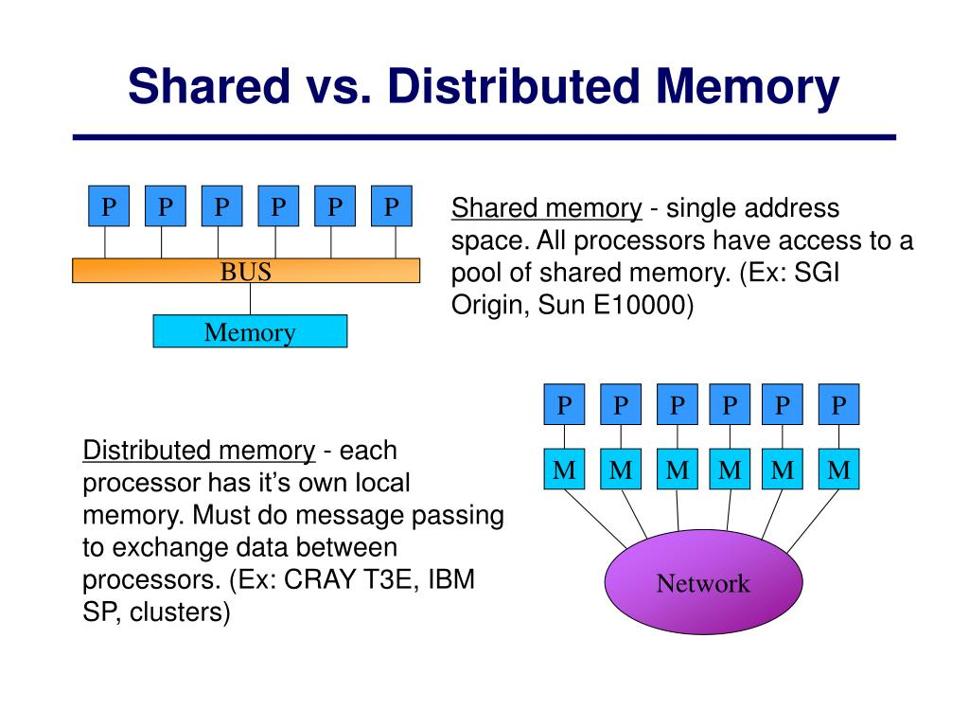

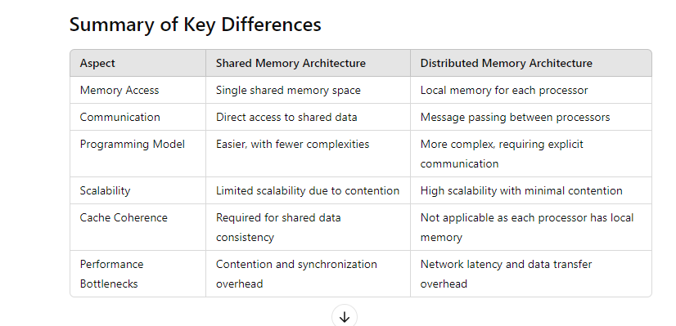
Feature | Shared Memory | Distributed Memory
Memory | Single global memory | Private memory per processor
Communication | Shared variables | Message passing (MPI)
Programming | Easier (threads, OpenMP) | Harder (explicit communication)
Scalability | Limited | Very high (thousands of nodes)
Speed | Faster local access, bottlenecks on bus | Local fast, remote slower due to network

10. Real-World Examples
- Top Supercomputers like Fugaku (Japan), Summit (USA).
- Cloud Datacenters using distributed clusters (Google, Amazon, Microsoft).
- Research Applications in physics, chemistry, biology simulations.

Message Passing in Distributed Memory Model
In a distributed memory model, each processor has its own private memory. Processors cannot directly access each other’s memory like in shared memory systems.
So, when one processor needs data from another, it must explicitly send and receive messages over a communication network (like Ethernet, InfiniBand, or interconnect fabric).
This is called the Message Passing Model.

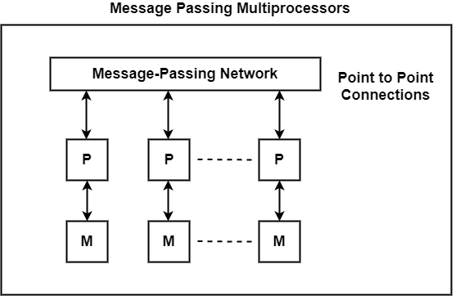

How It Works
- Local Computation – Each processor works on its local data stored in its private memory.
- Communication – When a processor needs data from another processor, it sends a message.
  - The sender calls a send operation.
  - The receiver calls a receive operation.
- Synchronization – Message passing inherently provides synchronization (receiver waits for sender’s data).
- Continuation – After data is transferred, each processor continues local computation.

Key Characteristics
- No global shared memory.
- Explicit communication through send/receive.
- Data locality is crucial for performance.
- Communication cost (latency + bandwidth) often dominates performance.

Advantages
- Scales well to very large systems (hundreds or thousands of nodes).
- Clear ownership of data (no race conditions like in shared memory).
- Easier to build across heterogeneous systems (different processors).

Disadvantages
- Programmers must explicitly handle data distribution & communication.
- Higher programming complexity compared to shared memory.
- Message passing overhead can reduce performance if not managed efficiently.

Examples of Message Passing Systems
- MPI (Message Passing Interface) → industry standard for HPC.
- PVM (Parallel Virtual Machine) → older system.
- Actor model in distributed computing (like in Erlang, Akka).

Diagram (simplified):
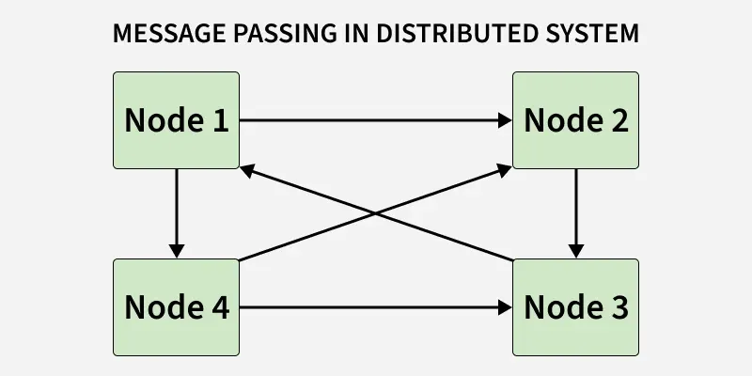
Each processor works on its own memory, but when needed, sends messages across the interconnection network.

